FRA Curated Resources for
NERDY BIRDY
By Aaron Reynolds & Matt Davies

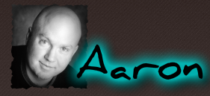 | Author, Aaron Reynolds:  http://www.aaron-reynolds.com  Meet Aaron Reynolds, the author of Creepy Carrots, President Squid and Nerdy Birdie. Find out what drives his unique style of writing and illustrating. (Bonus: he says second grade is his favorite grade)
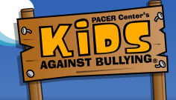 | Kids Against Bullying:  http://www.pacerkidsagainstbullying.org/kab/  What is bullying? How can you help? An interactive, kid-friendly site with quizzes, tips, and more!
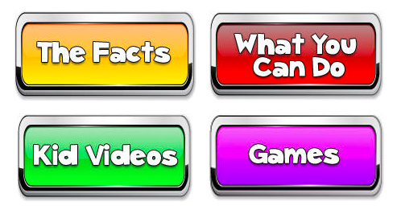 | StopBullying.gov:  https://www.stopbullying.gov/kids/index.html  Interactive website for kids to explore that includes games, fact sheets, tips and strategies to stand up and speak out against bullying. This is a one-stop shop site that also includes child friendly terms and videos.
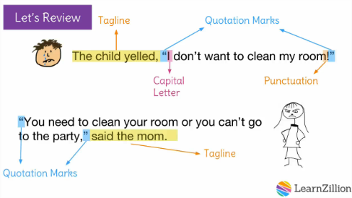 | Using Quotations – LearnZillion Video: https://learnzillion.com/lesson_plans/6903-use-quotation-marks-to-show-dialogue  Everybody loves LearnZillion for fun, easy videos that teach skills. Since there is a lot of dialog in this book, we have included this link to take you directly to the “quotations” lesson.  You can pair it with independent practice at http://www.studyzone.org/testprep/ela4/j/quotationmarksl.cfm (This one has less engaging pictures / word choices, but includes the practice piece for students).
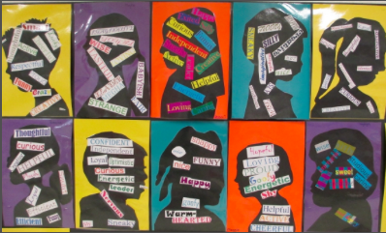 | Teaching Character Traits:  http://www.scholastic.com/teachers/top-teaching/2012/11/teaching-character-traits-readers-workshop  Need help creating a fabulous unit on character development? This is the scholastic article for you! This website has links to books, materials, ideas, and procedures to making a great unit on characters.
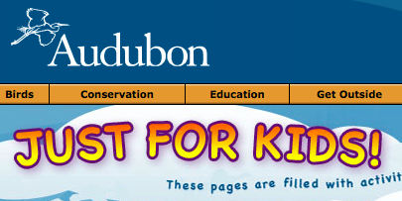 | Audubon for Kids:  http://web4.audubon.org/educate/kids/  Want to learn more about the birds in this book? Check out this site to play games, identify birds by their sounds, and other fun activities created to help children learn and understand more about birds.
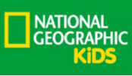 | National Geographic Kids – Birds:  http://kids.nationalgeographic.com/animals/hubs/birds/  National geographic has colorful fact sheets on all the birds your heart desires. If you are looking to pair this literature book with informational reading on birds, this is a great resource. Additionally, many science content standards (classification, adaptations, habitat, etc.) are addressed throughout the pages of National Geographic website. Double impact for your classroom!
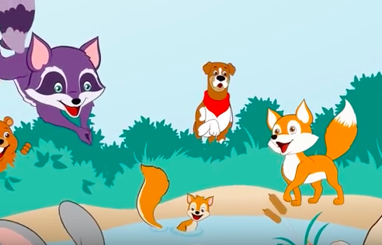 | How to Be a Friend Video:  https://www.youtube.com/watch?v=fpBxIpbN7XA  This song is a little slower for the whole class, but would be great as a listening center as the words on the video appear on the screen with easy to follow green highlighting to follow along. Just under five minutes long.
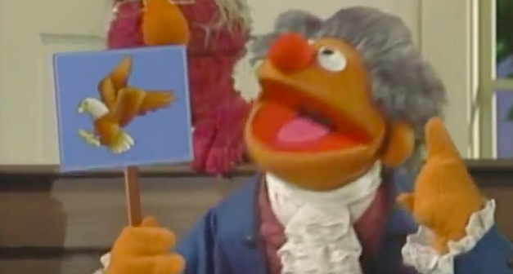 | Sesame Street Video - The National Bird:  https://www.youtube.com/watch?v=KC3Wjt1noQw  Watch this cute video on how the bald eagle became our national bird, and then hold your own classroom debate to see which bird should be your class or school bird!
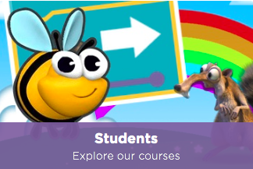 | Code.org:  https://code.org  Anyone can learn to code and create their own games! Check out this awesome site that teaches kids how to code through games!
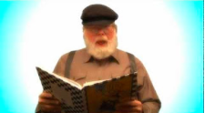 | Celebrities Read Children’s Books – YouTube:  https://www.youtube.com/playlist?list=PLbpi6ZahtOH6WqEc2d_xcPz0LXAbjfqUk  Think Betty White is all the rage? Or is the Beibs more your style? Regardless of who is super cool to your kids, there is a YouTube video for that! In this series, celebrities read their favorite books for all of us to enjoy.
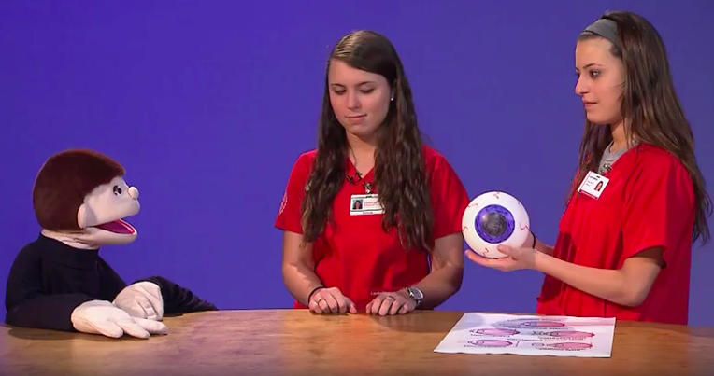 | Video – Why Kids Need Glasses:  https://www.youtube.com/watch?v=rJ6D1589GzQ  This short, simple video explains why some kids need glasses, and how glasses help people see better!
Are You a Nerdy Birdy?:
https://www.mensa.org/prominent-mensans
Maybe you are a nerdy birdie! Check out which famous people are members of the “super smart” club called Mensa! Only 2% of the population can get in. IQ changes, so with hard work and effort, you could become a Mensan. Check out the pretest to see how close you are or explore more about the organization itself. Teachers might want to print out pictures of the actual people (and their salaries wouldn’t hurt to really drive home the point that is cool to be smart!!!).
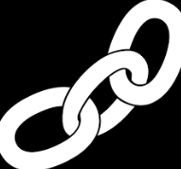 | Extension Activity – Fact vs. Fiction:  Some parts of “Nerdy Birdy” are factual, and other parts are made up, (i.e.: Vultures do eat dead things, but birds don’t use :banana” laptops). Have students look through the book to create a chart identifying factual and fictional info from the book.
Extension Activity - Classifying:
There are many different types of birds in this book, with different characteristics. Have students classify them using teacher- or student-created headings.
Extension Activity – Never Ending Story:
“Nerdy Birdy” ends with Nerdy Birdy and Vulture meeting a new bird. What will happen next? Have students extend the book to create a new ending!

